New England Wheelchair Tennis Camp/Certification
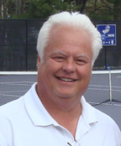
USPTA REGIONS TOP WHEELCHAIR TENNIS PROFESSIONALS
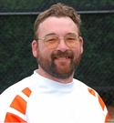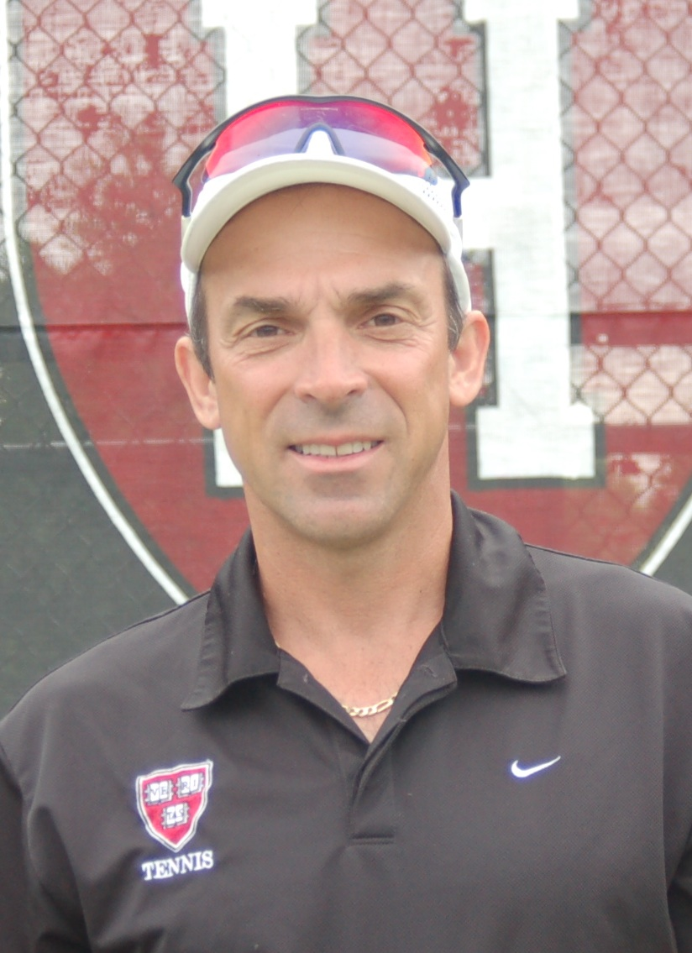
Dick Lane Michael Mercier Greg Coache
Held @ Harvard University’s Murr Indoor Tennis Center
AUGUST 12, 13, 14

Michael Mercier is a USPTA National Wheelchair Tester, USPTA New England Vice President, Chair for USTA New England Wheelchair Tennis, Harvard University Head Tennis Professional, USTA High Performance Coach, 2010 USPTA New England Diversity Tennis Professional of the Year. Former USA Wheelchair Tennis Coach
Greg Coache is a USPTA (wheelchair) certified teaching professional, USTA tennis official, Southern New Hampshire University Head Tennis coach for women and men’s teams, USTA New England–New Hampshire Wheelchair ambassador and was recently named USPTA New England Tennis Coach of the Year.
Dick Lane is a USPTA Wheelchair Tennis professional and in 2008 was named the USPTA New England Wheelchair Tennis Professional of the Year. Lane is a USTA player and the wheelchair ambassador for USTA New England–New Hampshire.
CAMP SCHEDULE OF EVENTS (fee - $125 for all 3 days. Scholarships available by need.)
Friday, August 12 (12 p.m.–6 p.m.):
Wheelchair Tennis Camp/USPTA Wheelchair Certification – on court
For USPTA Wheelchair Certification, contact Vicky @ vicky.tristan@uspta.org and visit www.uspta.com
Saturday, August 13 (9 a.m. – 8 p.m.):
Wheelchair Tennis Camp/USPTA Wheelchair Certification and advanced training– on court
Celebrity Guest Appearances from Boston Professional Athletes
Sunday, August 14 (10 a.m. – 4 p.m.):
Continued Wheelchair Camp with Match Play
WTT Team mixed format match play (One up/one down)
Wheelchair Tennis Fundraiser / Celebrity Match Play / USPTA “Free Tennis Across America” for Harvard Community
For further information, please contact: Michael Mercier at mercier@fas.harvard.edu or 978-273-6500
www.competitiveedgetennis.com www.newengland.usta.com/Wheelchair/1919_Wheelchair_Tennis/

